IS-1607k Kassenov Zholaman

Project name: Online furniture shop “FurniSHOP”

**Report**

Microservices for Online shop “FurniSHOP”

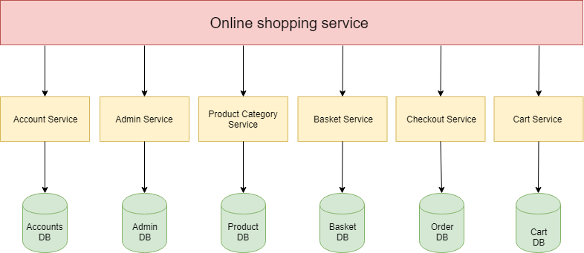

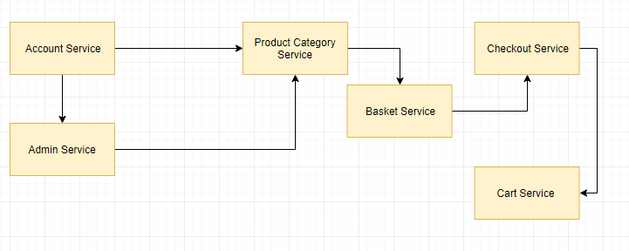

**Account Service:**

* User login
* User Registration
* Admin Login

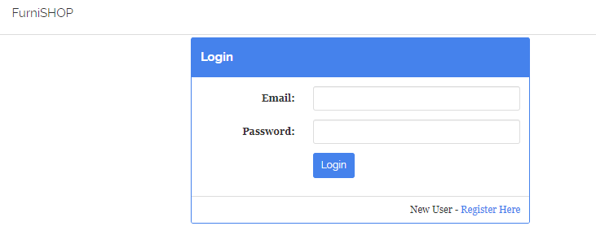

**Admin Service:**

* Add Product
* Update Product
* Delete Product

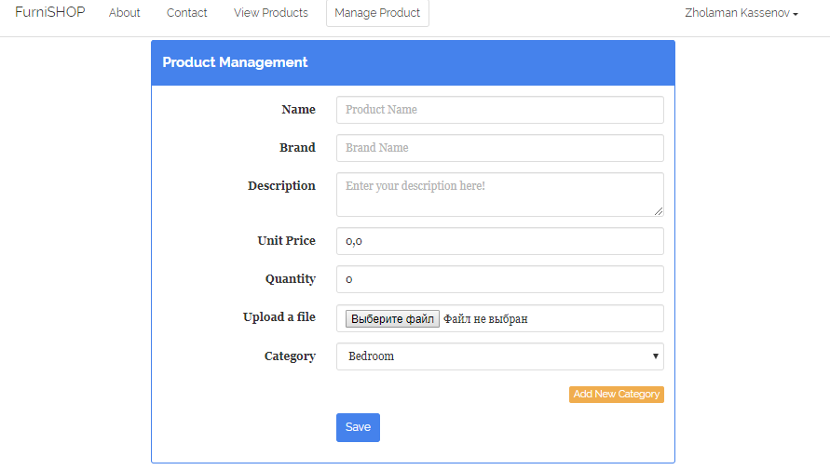

**Product Category Service:**

* View product
* Update product
* Add Product to basket

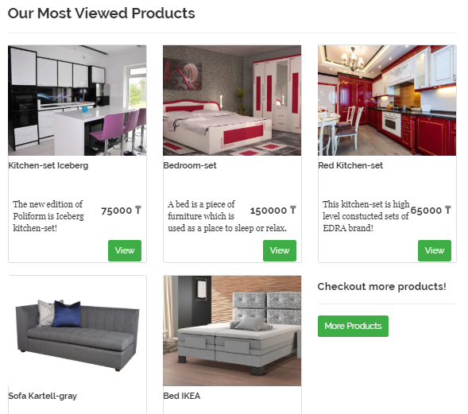

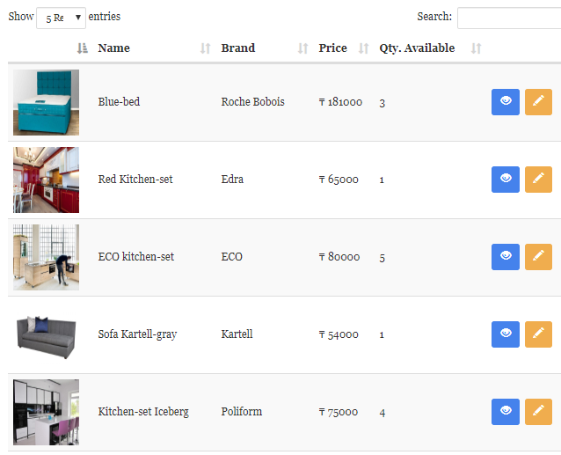

**Basket Service:**

* View products
* Move to basket
* Delete from basket
* Checkout basket

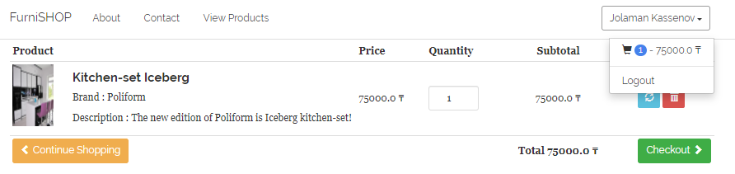

**Checkout Service:**

* Add Address
* Select Address

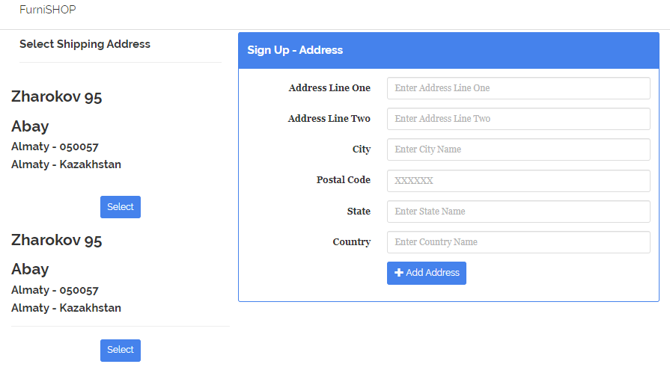

**Card Service:**

* Add card
* Pay

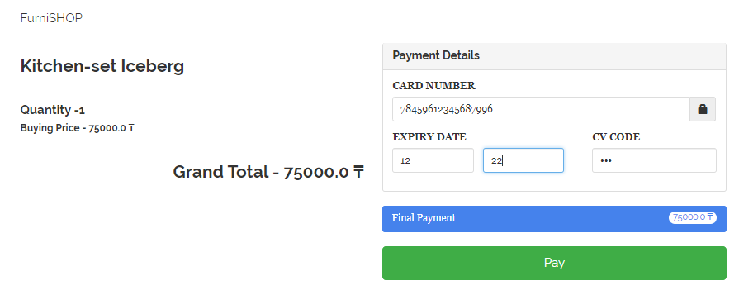

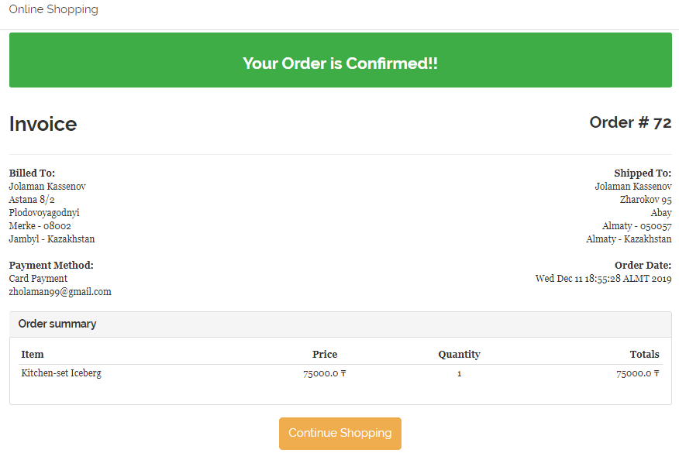

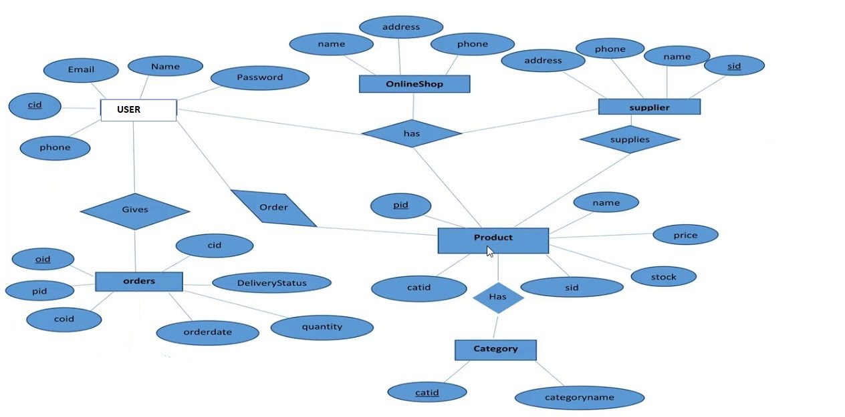

ER diagram for Online shop

DataBASE H2 console

